Lab 2 Placeholder

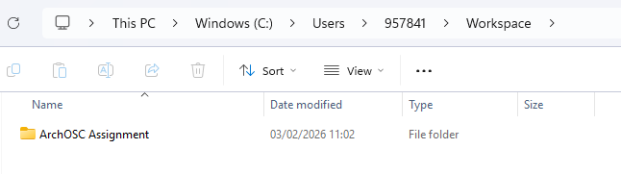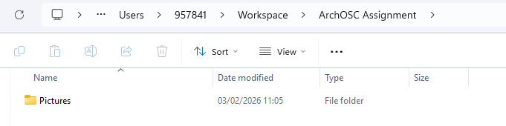

I have created new folders in my Workspace, naming them ArchOSC Assignment and Pictures.

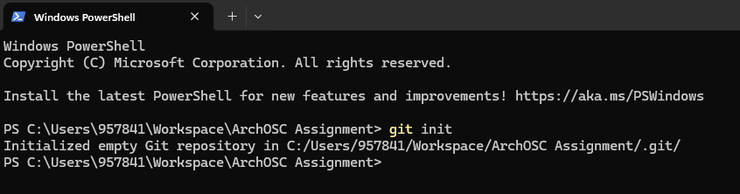
I have opened a terminal inside of the ArchOSC Assignment folder and typed in git init, showing it initialized an empty git repository in that folder.

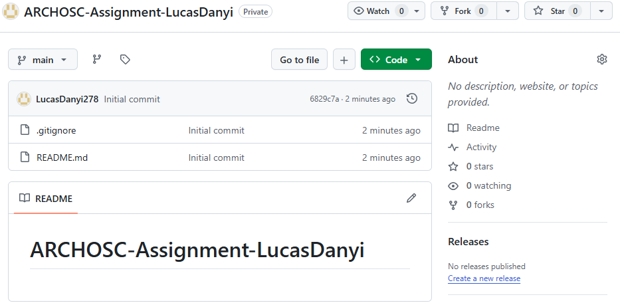

I have created an online Github repository.

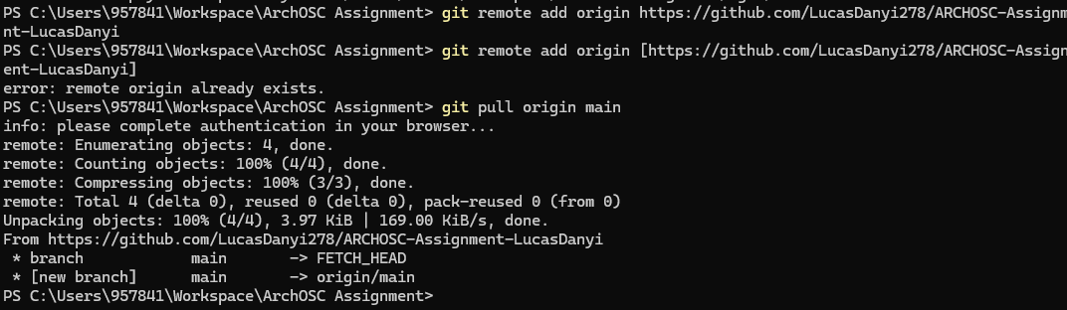
I have used the terminal to connect the local Github repository to the online Github repository.

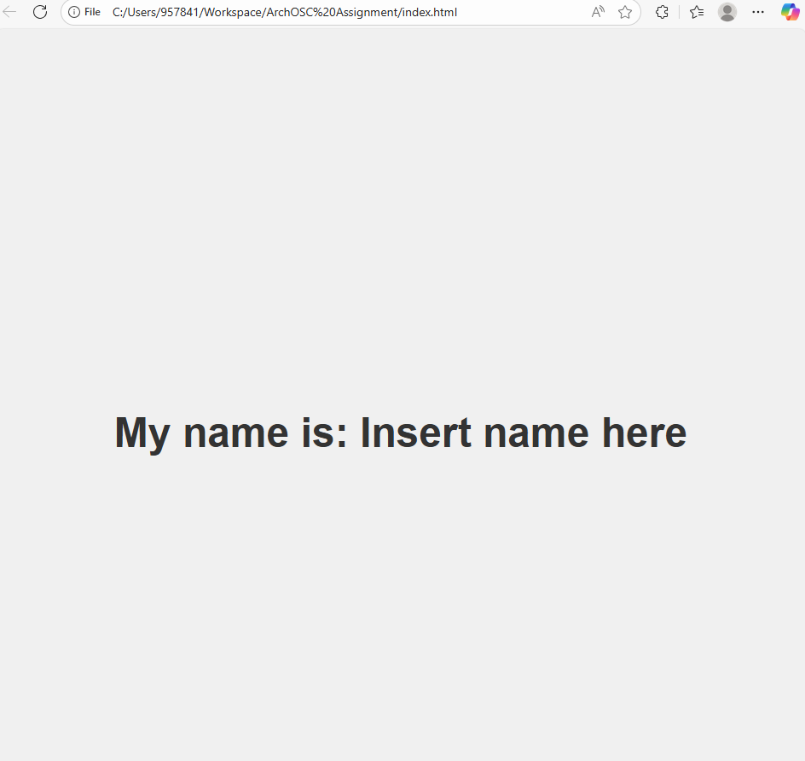

I have opened visual studio code, and copied code in. Then, I have opened the html file from the workspace and got this as an output.

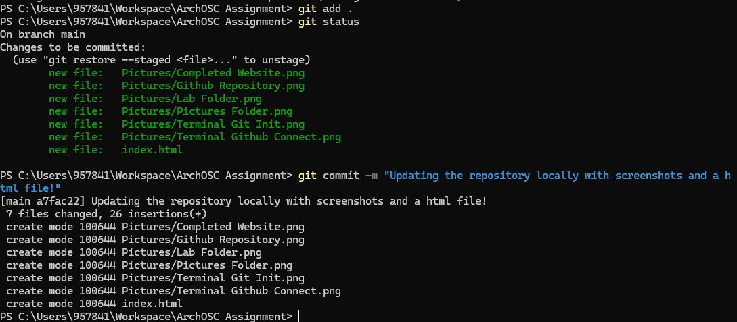
I have used git commands to add and update files into my local repository.

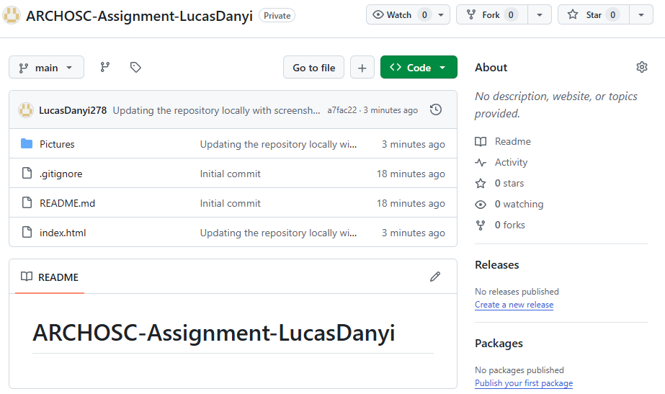
I have used the terminal to update my online repository to match my local repository.

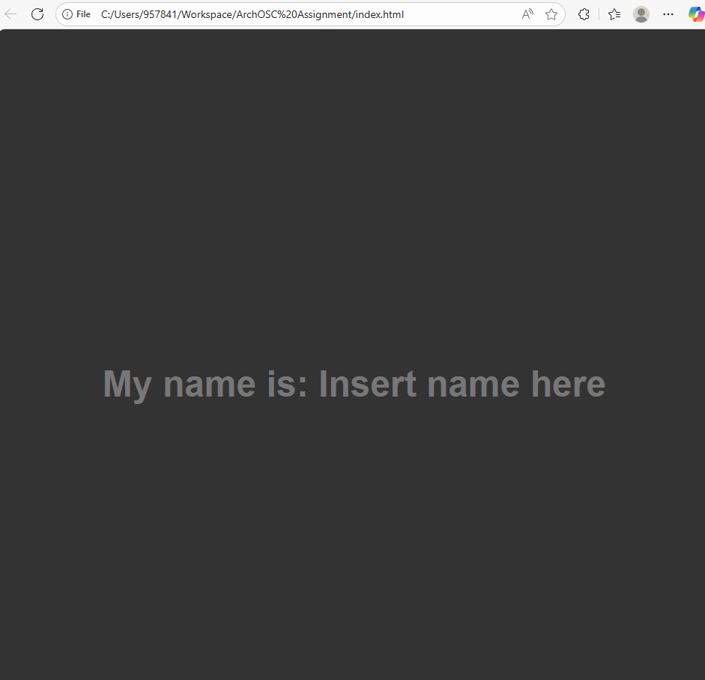
Update 1: I have changed the colors of the background, and the text.

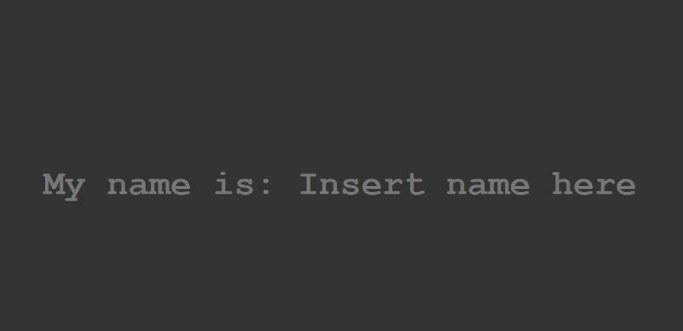
Update 2: I have changed the font of the text in the website.

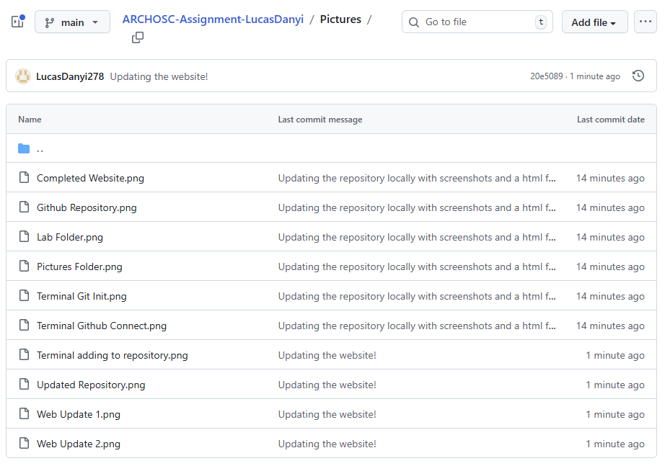
Pushing the updated files into the online repository.

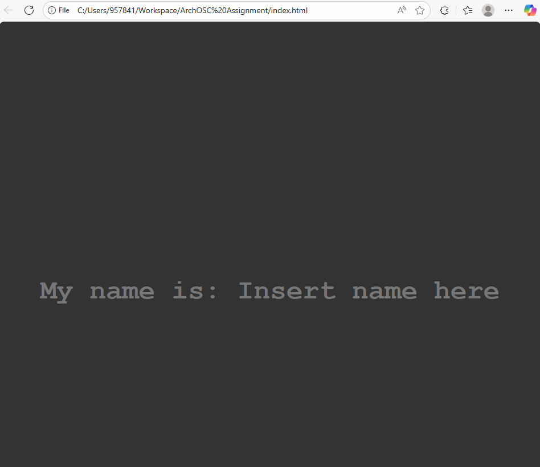
I have accessed the website from Github deployments.

